SELECT nama_pelanggan, nama_obat, jenis_obat as 'jenis Obat', alamat, total_bayar

FROM pelanggan a

JOIN penjualan b

ON a.id_pelanggan= b.id_pelanggan

JOIN penjualan_detail c

ON b.id_transaksi = c.id_transaksi

JOIN obat d

ON c.id_obat = d.id_obat

WHERE jenkel_pelanggan LIKE 'Perempuan'

AND alamat LIKE '%B%'

ORDER BY nama_pelanggan ASC;

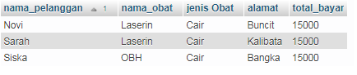

SELECT nama_pelanggan, b.id_pelanggan, tgl_transaksi

FROM pelanggan a

JOIN penjualan b

ON a.id_pelanggan = b.id_pelanggan

JOIN penjualan_detail c

ON b.id_transaksi = c.id_transaksi

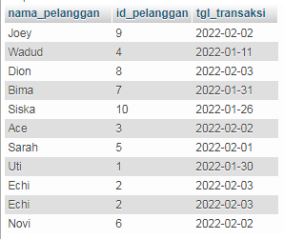

SELECT a.id_transaksi, nama_obat, stok, harga_obat

FROM penjualan a

JOIN penjualan_detail b

ON a.id_transaksi = b.id_transaksi

JOIN obat c

ON b.id_obat = c.id_obat

WHERE jenis_obat = 'tablet';

